**SYSTEM ANALYSIS**

It involves investigating a system, identifying the problems and using the information recommended to system. Also the understanding of how things are done and checking if the proposed system would be viable. System analysis involves:

1. Data Collection
2. Feasibility Analysis
3. Requirements Analysis
4. System Modelling

**Data Collection**

Data collection was conducted in few homesteads in Murang’a County which practised dairy farming. It was carried out to collect information from the dairy farmers about the proposed system. The following methods were used for data collection:

1. Informal interview
2. Observation
3. Written Documents and Online Documents.

**Informal Interview.**

Dairy farmers were interviewed to obtain information and their view about the development of the system. In addition, what records they kept for their cattle, access to internet services and if they were able to assess the profitability of their farming.

Findings from the interview:

Most of the farmers kept records on the milk they sold. They wrote it down on an exercise book and cancelled off when they got paid. All the farmers interviewed had mobile phones and could use the sms service. Records on insemination and treatment, they just kept the receipt given by veterinary doctor. They had a challenge when they lost/misplaced the exercise book recorded amount of milk sold. Some had mobile phones which could access Internet services. Some of the farmers had challenges in knowing what profit they got from the farming. They responded positive on having a way they can store their records online.

**Observation**

From observation most of the farmers had average of 2 cows. Their milk production record was shallow, as it just included the amount of milk they had sold. From the receipts given by the veterinary doctors, got information on what the insemination record should contain.

**Written Documents and Online Documents**

Online and written documents were reviewed to get information on what records the dairy farmers should keep and the details of the records.

**FEASBILLITY ANALYSIS**

Feasibility analysis is the process by which project feasibility is measured. A feasibility study was done to find out whether the proposed system was viable in terms of economic, schedule, technical and operation feasibility.

This is the test of the proposed system in terms of its workability meeting users’ requirements, effective use of resources and cost effectiveness.

**Economic feasibility**

It involves checking whether the system would be affordable to build and maintain. In terms of the resources required; most of the tools are freely available and accessible. Once the system is deployed it has potential of generate income.

### Technological feasibility

A technological feasibility study revealed that the technology required to develop the system is available and with the increase use of the internet and mobile phones, the system would be able to target a large number of farmers.

### Schedule feasibility

According to the work schedule of completing this project, approximately 1.5 months has been allocated for the development of the system which is enough time to design, test and evaluate the system successfully.

**Technical feasibility**

This study involves checking the availability of hardware, software and personnel for building and running of the system. The proposed system was found to be technically feasible since it would not require staff to operate it and the required hardware and software to design and maintain the system is available.

### Operational Feasibility

It was necessary to change the current method of storing records by farmers from manual to electronic. The target audience being farmers, having tips and help tools could assist them to easily use the system.

**Functional Requirements**

**Farmer**

1. Unregistered farmers can register.
2. Registered users’ can login in the system.
3. Registered farmers’ to add new cows’ details in the system.
4. Farmer can delete a record or update a record.
5. The farmer can set activities reminders and then get reminders via sms.
6. A farmer can generate reports from the record stored
7. A farmer can view records of his/her cows.
8. The farmer can update income, expense, and milk production records using the SMS service.

**System**

1. The system should interact with the SMS gateway to enable receiving and sending of messages to the users.
2. The system should send login password to the user via SMS.
3. The system should analyse the income and expenses of the farmer and send results via SMS.

**Non-functional requirements.**

1. The system should be secure, only authorized users are allowed to log in and use the system.
2. Efficiency response time performance and page generation speed.
3. The system should be usable, has tips displayed on each page and provide a concise interface for users.
4. The system should be reliable in user input validation.
5. The system should be stable, be available to multiple users who have logged in at the same time and using the system simultaneously.

## System Analysis Models

### Use Case Diagrams

These are diagrams that were used during the analysis phase to identify and split functionality of the system. They are made up ofactors and use cases. Actors represent the various external people or entities that interact with the system.

The use case of the system consists of one actor (farmer):

The activities carried by the farmer include:

1. Registering/ Login
2. Viewing records
3. Adding new cows details.
4. Updating records.
5. Deleting records.
6. Setting reminders.
7. Generating and viewing reports.

USER CASE DIAGRAM

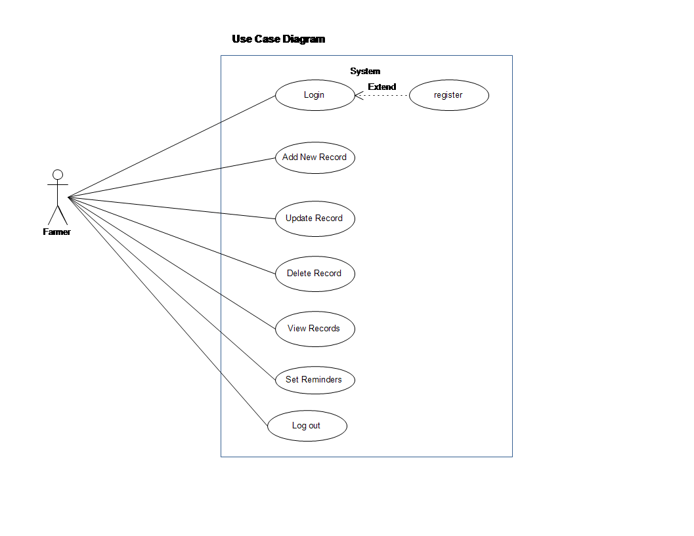

Fig 1. Use case diagram.

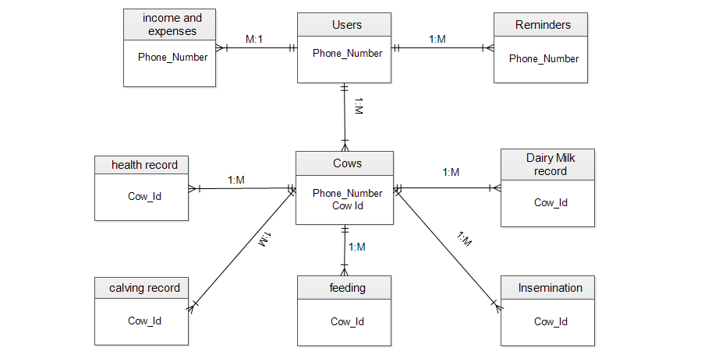

Fig 2. Entity Relationship Diagram

**SYSTEM DESIGN**

Architectural Design

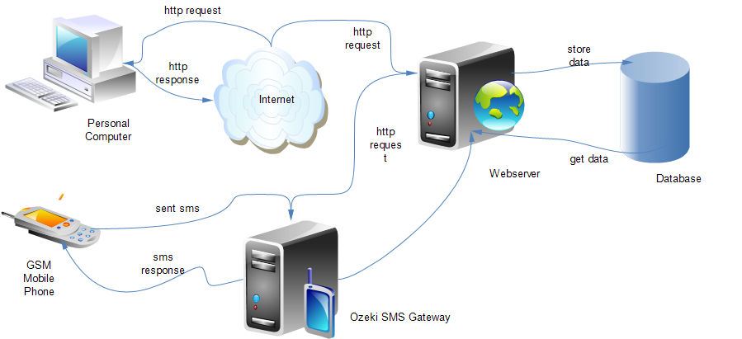

Fig 3. Architectural Design diagram

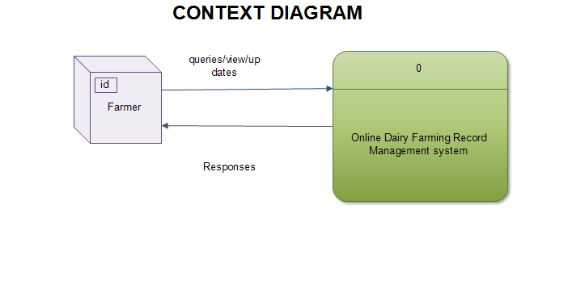

Fig 4. Contex diagram.

**Dataflow Diagram**.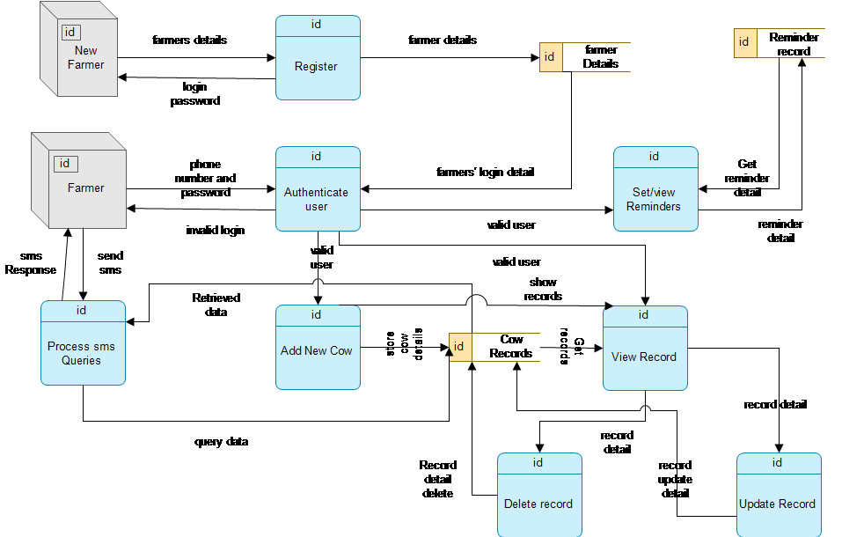

Fig 5. Dataflow diagram